# Alerts :

<https://flowbite.com/docs/components/alerts/>

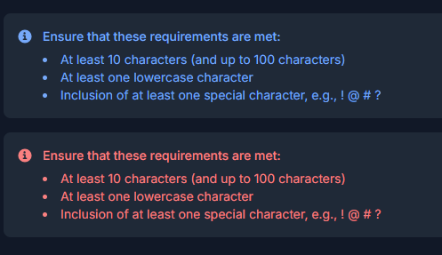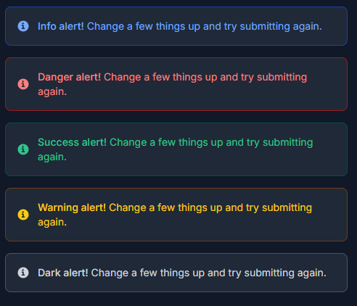

# Rounded avatar

<img class="w-10 h-10 rounded-full" src="/docs/images/people/profile-picture-5.jpg" alt="Rounded avatar">

<img class="w-10 h-10 rounded" src="/docs/images/people/profile-picture-5.jpg" alt="Default avatar">



# Circular progress loading

import * as React from 'react';

import CircularProgress from '@mui/material/CircularProgress';

import Box from '@mui/material/Box';

export default function CircularIndeterminate() {

return (

<Box sx={{ display: 'flex' }}>

<CircularProgress />

</Box>

);

}



# List component for post uploading section

<https://www.hyperui.dev/components/application-ui/details-list>

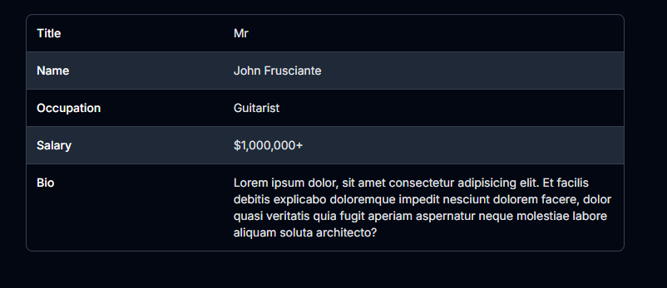

# Side menu components

<https://www.hyperui.dev/components/application-ui/side-menu>

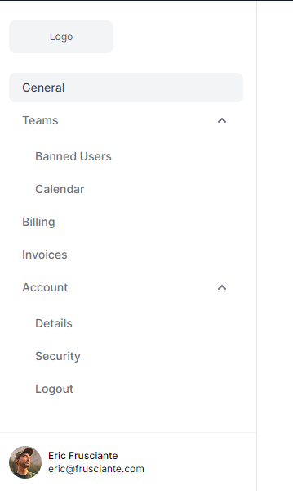

# Text box for caption in post uploading

<https://www.hyperui.dev/components/application-ui/textareas>

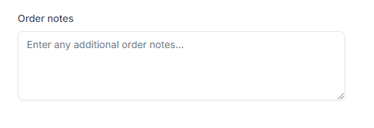

# Sign in pop up for search section without login

<https://www.hyperui.dev/components/marketing/announcements>

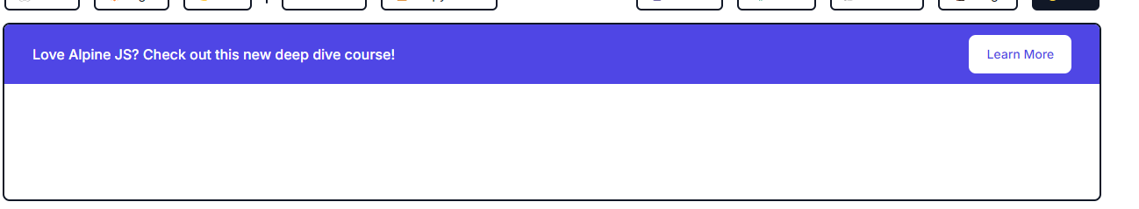

# POST card components

<https://www.hyperui.dev/components/marketing/blog-cards>

# 

# Footer components

<https://www.hyperui.dev/components/marketing/footers>

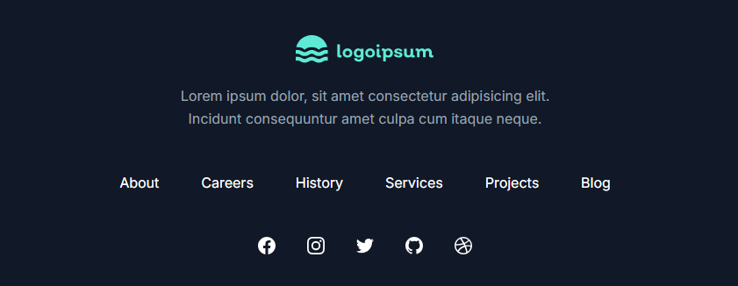

# Header components

<https://www.hyperui.dev/components/marketing/headers>

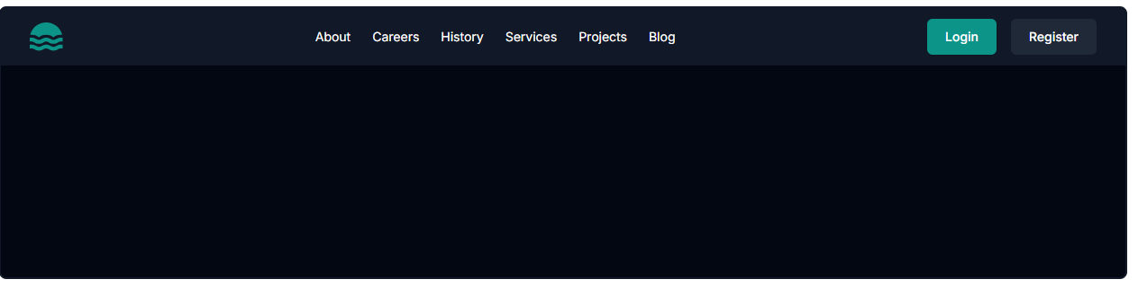

# Search bar with drop down

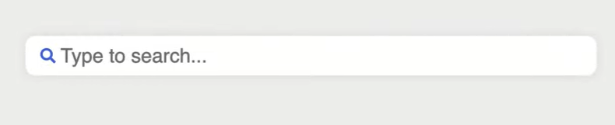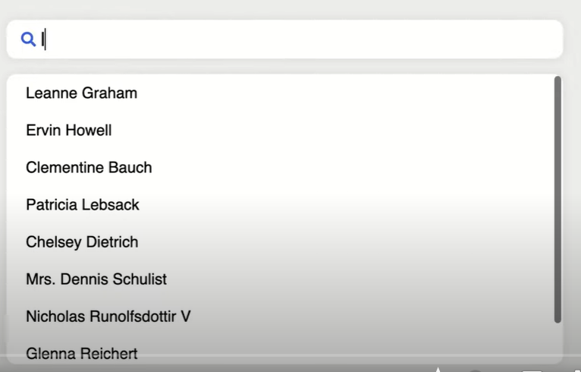

<https://github.com/CodeCompleteYT/react-search-bar>